10 Easy DIY Improvement Projects You Can Do With Your Kids
Instead of allowing your children to grow up believing that they need a handyman to take care of any repair or maintenance job in the house, you should teach them to be their own superheroes. Teaching them how to do numerous small repairs all over the house will build their confidence. And with time, they can upgrade to bigger projects. So here are some easy projects that you can do with your kids:

Easy DIY Projects You Can Do With Kids

Building a Birdhouse
Nothing brings your backyard to life than a family of colorful birds living in your garden. And building birdhouses can help attract them to your backyard and allow you to work with your kids. For this project, you will need a high-quality router table, sliding miter saw, drill, hammer, and a hole saw.
The birdhouse’s sidewalls are made using some 12mm thick pieces of plywood with an 8mm groove on the edge and 6mm on either side. These grooves can be made using either a router or a table saw. Prepare the front, base, and back before assembling the birdhouse using nails and wood glue. Add the roof and then finish with a hole and perch. For easy cleaning, you can make sure it has a removable floor.
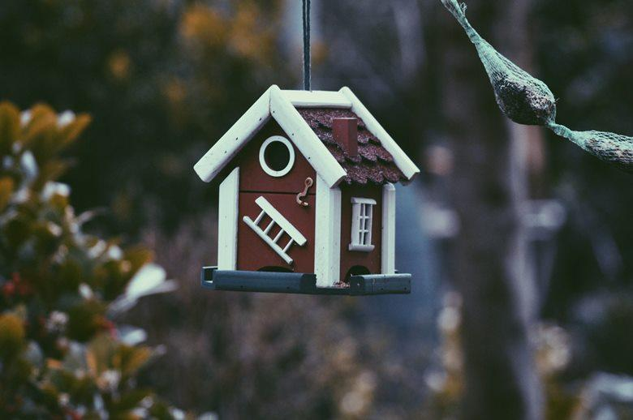
Photo by Harmen Jelle van Mourik on Unsplash

Fix Squeaky Hinges
One of the simple projects that you can teach your kids is silencing all the squeaky hinges in the house. Your kids can start by first locating all the squeaky hinges in the house and then show them how to silence them using olive oil and WD-40. You can do one or two hinges and then let them silence the other squeaky hinges. But, don’t forget to give them a piece of cloth to place below the spray or olive oil as it tends to drip. Another solution for squeaky hinges is petroleum jelly, which doesn’t run like olive oil or WD-40.
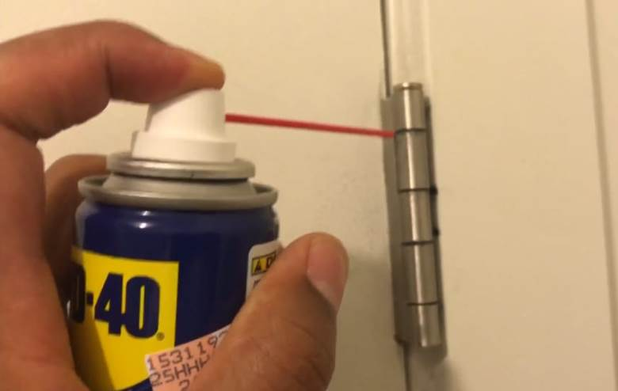
Source: https://www.youtube.com/watch?v=msdhuJQBkE0

Tighten the Cabinet and Drawer Hardware
Another easy repair job that you can teach your children is tightening all the drawers and cabinet hardware in the house. The lefty-loosey and righty-tighty trick will stick with them as they handle bigger tasks in the future. You can also allow them to replace old hardware with new ones. All they will need is your guidance and a screwdriver.

Silence Creaky Floors
Hinges are not the only things in your house that creak. Wooden floors tend to squeak because the boards are rubbing against the sub-floor or each other. This project is relatively easy, and your child can help you take care of this problem within a few minutes. All you need for this project is to sprinkle powdered graphite, soapstone powered, and talcum powder in the creaking regions.

Paint Jobs
Painting jobs are some of the easiest DIY tasks that can be fun for kids. You can start with a small task like repainting one of the furniture in the house or the mailbox before upgrading to the walls. Teach them how to paint neatly and the importance of using the same color all over the house. Once they are older, they can take part in bigger projects like repainting the entire house or fence.

Cleaning the Faucet Aerator
When faucets start spraying water to the side or lose pressure, the problem is usually dirty aerator screens. And the solution to this problem is cleaning the aerator screen, but first, you have to disassemble the aerator and then soak the screen in vinegar. All you need for this task is vinegar for soaking the screen, an old rag, and pliers.

Hanging a Picture
Hanging a portrait is more than just hammering a nail into the wall and hanging the photo. Hanging portraits is an art that must be done correctly, making sure that it’s leveled. Therefore, the sooner your kids learn that, the better they will be in their own homes in the future. The first step to hanging a portrait is selecting an attachment. The most common types of attachments that you can use for this project are D-ring and sawtooth.
If your portrait comes with some D-rings and no wire, you can attach the hanging wire and then position your portrait. Once you have determined where you want to place the photo, you can choose the hanger. Hammer in the nail to the marked spots on the wall and then hang your portrait. But make sure it’s leveled.

Change the Furnace Filter
You can add replacing furnace filters to your child’s to-do list. Checking the furnace filter regularly will mean that you will know when it gets dirty and need to be replaced. Remember, a clean filter can keep the HVAC system running smoothly. So teach them how to monitor the furnace filter once per month and inform you when it’s dirty or needs replacement.

Create a Book Nook
You can make learning fun for your child by creating a book nook. You can give your home a rustic feeling by arranging their books in wooden crates. You can start by purchasing some vintage Wooden crates in the local store and then let your kids pick the colors for the wooden boxes. Paint your wooden crates and stack them together with varying height along their playroom’s wall. You can add a cozy bean-bag seat. A beautiful book nook can motivate your kids to read more.

Give Old Furniture a New Look
Upgrade some of the furniture like a bookcase, shelf, or end table using some decorative shelf linings. This simple project involves measuring the size of your furniture and then cutting the lining to size. Remember, the shelf lining adheres to any surface. Make sure you have a credit card to help you smooth out the bubbles that can pop up while you are remodeling your furniture. This simple project can teach them how to upgrade old furniture in their homes in the future instead of purchasing new ones.

Final Thoughts
Teaching your kids how to take care of numerous small repairs in the house can save you money and time. But at the same time, it can teach your kids to be responsible and boost their confidence. Doing these simple improvement projects can be a great bonding moment for the entire family.

